Pareto improvement: someone can gain, and no one needs lose when resources are allocated inefficiently

Beneficiaries can fully compensate the losers and still have some benefits left over, generating a Pareto improvement

Net Return = B(benefits) – C(costs)

Efficiency of the competitive equilibrium

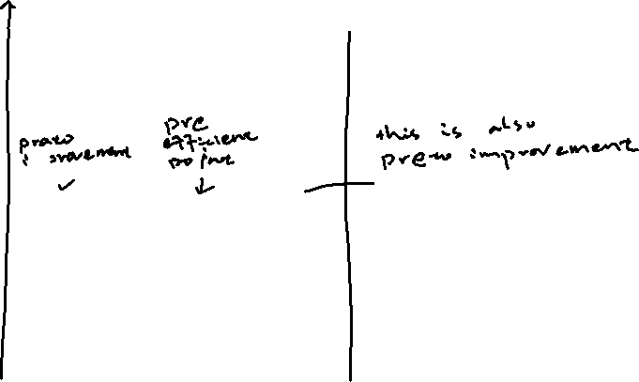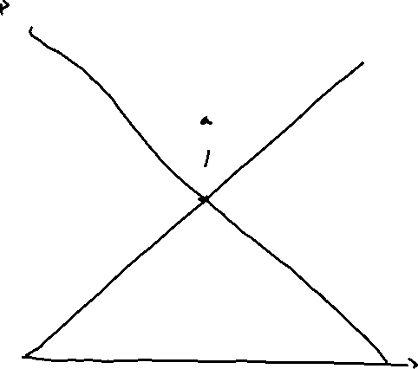

1. Any movement to the equality point is the pareto improvement.
2. The second fundamental Theory of welfare Economics states that society can attain any Pareto efficient allocation of resources – one that is more equitable by making a suitable assignment of initial endowment s and then letting people freely trade with each other.
3. Equity can be achieved without inhibiting efficiency

Consumer Surplus

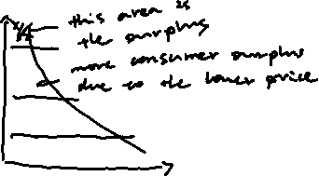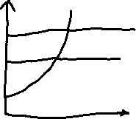

Should who gains and who loses be taken into account? Should benefits and costs be weighted?

NO: a project should be undertaken if it has positive net present value, regardless of distributional consequences

NO: let the government costless correct any undesirable distributional aspects

NO: relies too much on value judgments and politics

Project evaluation usually requires comparing costs and benefits from different time periods

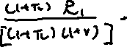

Starting point: a private fries point of view.

A project is admissible only if its net return is positive that is, the benefits exceeds the costs

If both projects are admissible, the firm should choose the project with the higher net return